1. **Hello world:**

* Room name and link: <https://tryhackme.com/room/hello>
* Learning objective: Introduction to the TryHackMe platform.
* Key tools/commands used: N/A (web based only)
* Concepts learned: Basic platform navigation and task completion.
* Walkthrough/ How you solved it: Followed the introductory tasks.
* Reflections/ Notes: Initial familiarization with the environment.

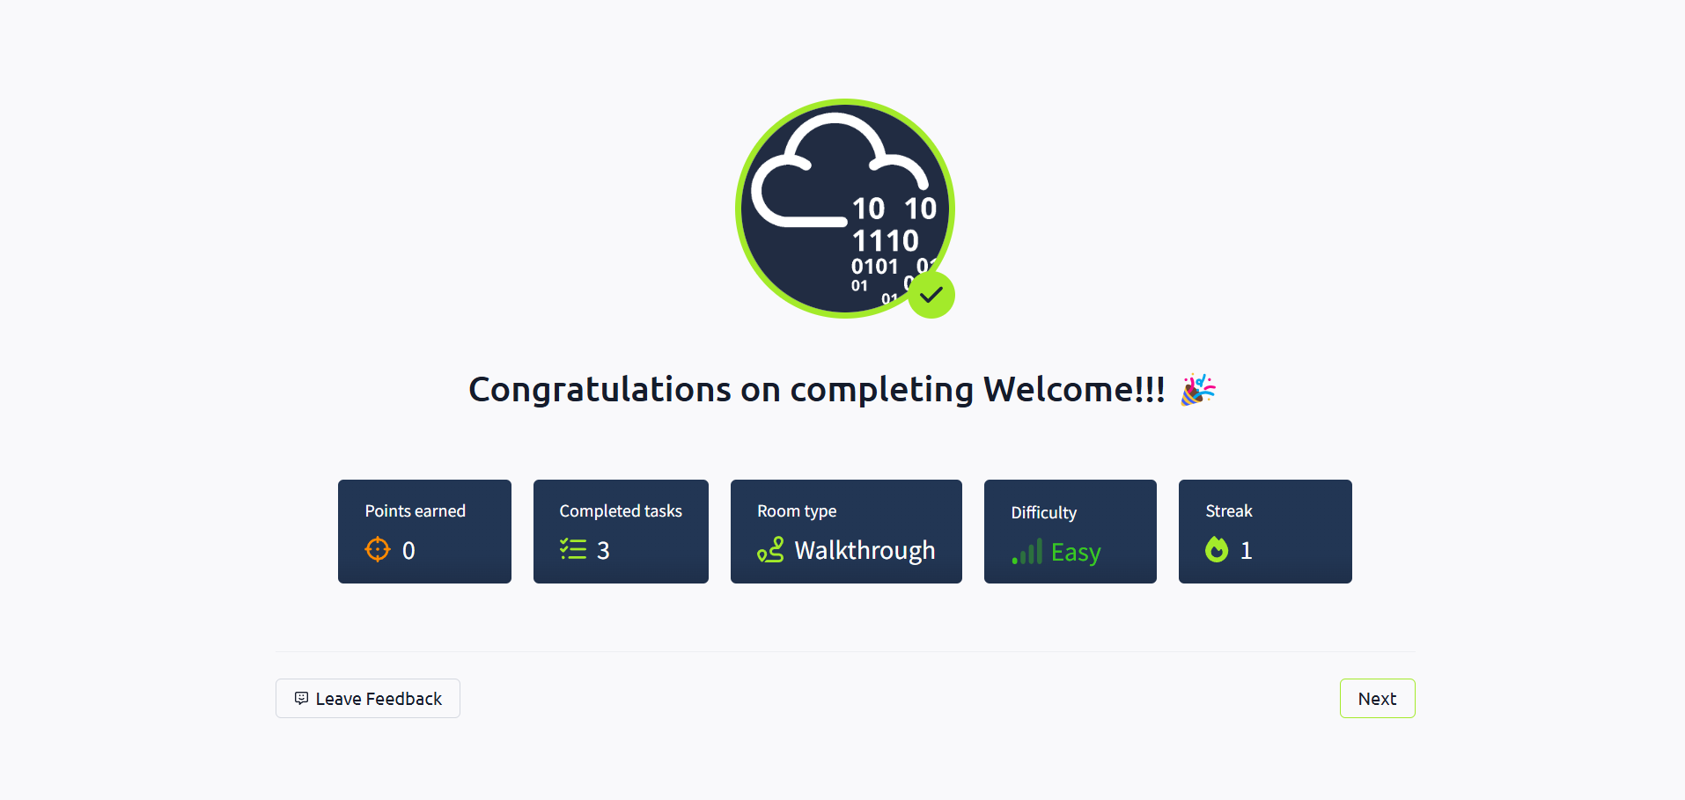

1. **How to use TryHackMe:**

* Room name and link: <https://tryhackme.com/room/howtousetryhackme>
* Learning objective: Understanding platform features and functionalities.
* Key tools/commands used: N/A (instructional content only)
* Concepts learned: Utilizing hints, completing challenges and submitting answers.
* Walkthrough/ How you solved it: Explored the described features and completed the associated tasks.
* Reflections/ Notes: Developed a better understanding of how to interact with the platform.

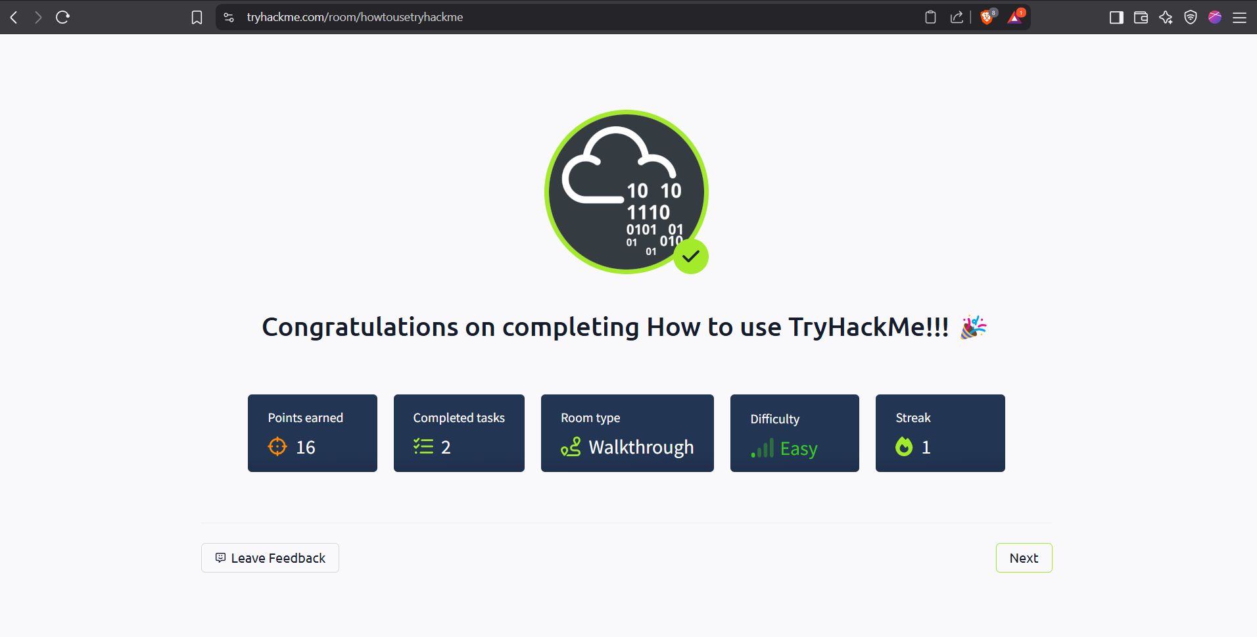

1. **Getting started:**

* Room name and link: <https://tryhackme.com/room/gettingstarted>
* Learning objective: Initial steps for engaging with TryHackMe account.
* Key tools/commands used: N/A (web based only)
* Concepts learned: Joining rooms and deploying the virtual machines.
* Walkthrough/ How you solved it: Followed the instructions for joining and deploying. Checked the view source page to get the necessary infomarion.
* Reflections/ Notes: Prepared the environment for further learning.

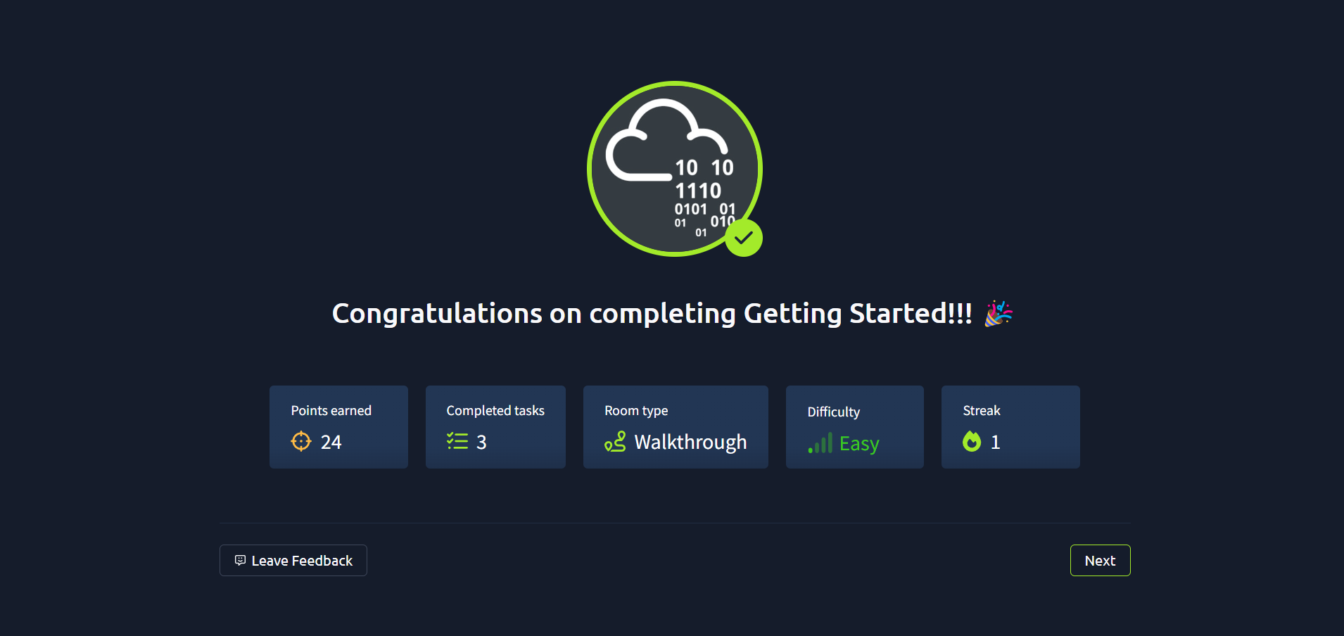

1. **TryHackMe Tutorial:**

* Room name and link: <https://tryhackme.com/room/tutorial>
* Learning objective: Learn to interact with virtual machines and submit answers using the platform.
* Key tools/commands used: Web terminal, file system navigation.
* Concepts learned: Command line basics, web-based interaction.
* Walkthrough/ How you solved it: Used web shell as directed, navigated files, and followed step-by-step instructions.
* Reflections/ Notes: Bridges the gap between theory and practice, excellent for absolute beginners.

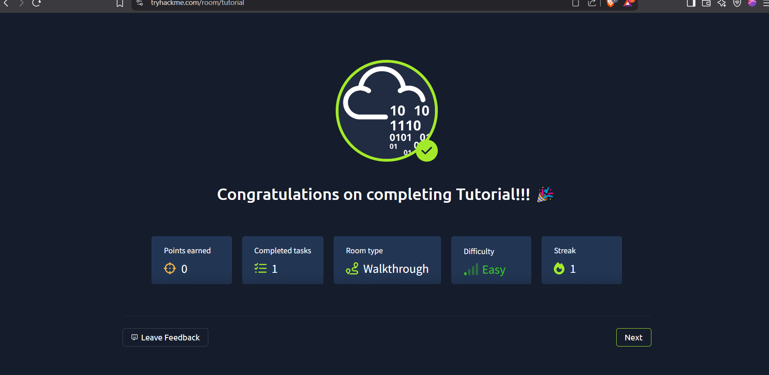

1. **OpenVPN Connection:**

* Room name and link : <https://tryhackme.com/room/openvpn>
* Learning objective: Succesfully connect to TryHackMe’s network using OpenVPN.
* Key tools/commands used: openvpn, .ovpn configuration files.
* Concepts learned: Secure remote connectivity, IP verification..
* Walkthrough/ How you solved it: Downloaded the VPN configure, launched OpenVPN and confirmed connection using IP info.
* Reflections/ Notes: A foundational step before beginning hands-on rooms with dedicated machines.

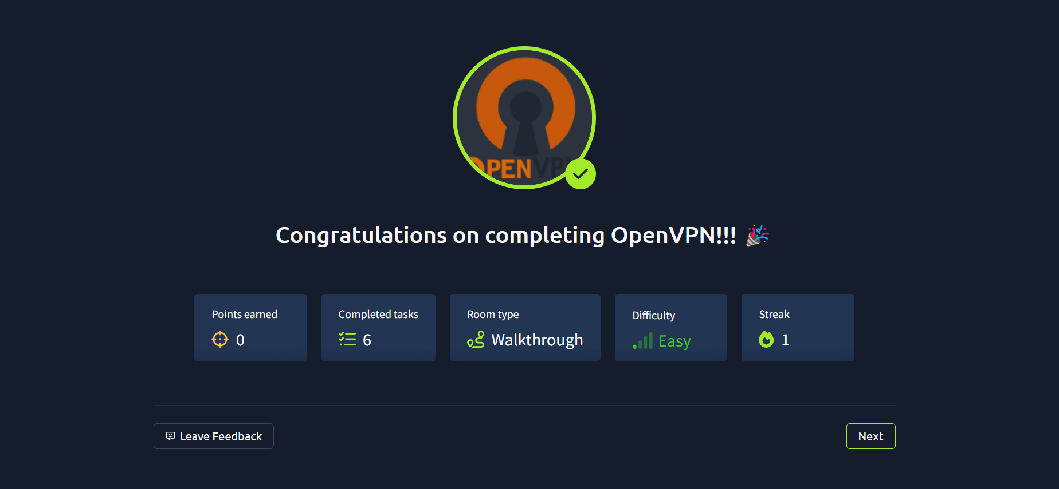

1. **Beginner Path Introduction:**

* Room name and link: <https://tryhackme.com/room/beginnerpathintro>
* Learning objective: Overview of the learning path for newcomers.
* Key tools/commands used: None.
* Concepts learned: Structure and content of the beginner learning track.
* Walkthrough/ How you solved it: Reviewed the path overview and its components.
* Reflections/ Notes: Understood the recommended learning progression (web application security and networking basics) for beginners.

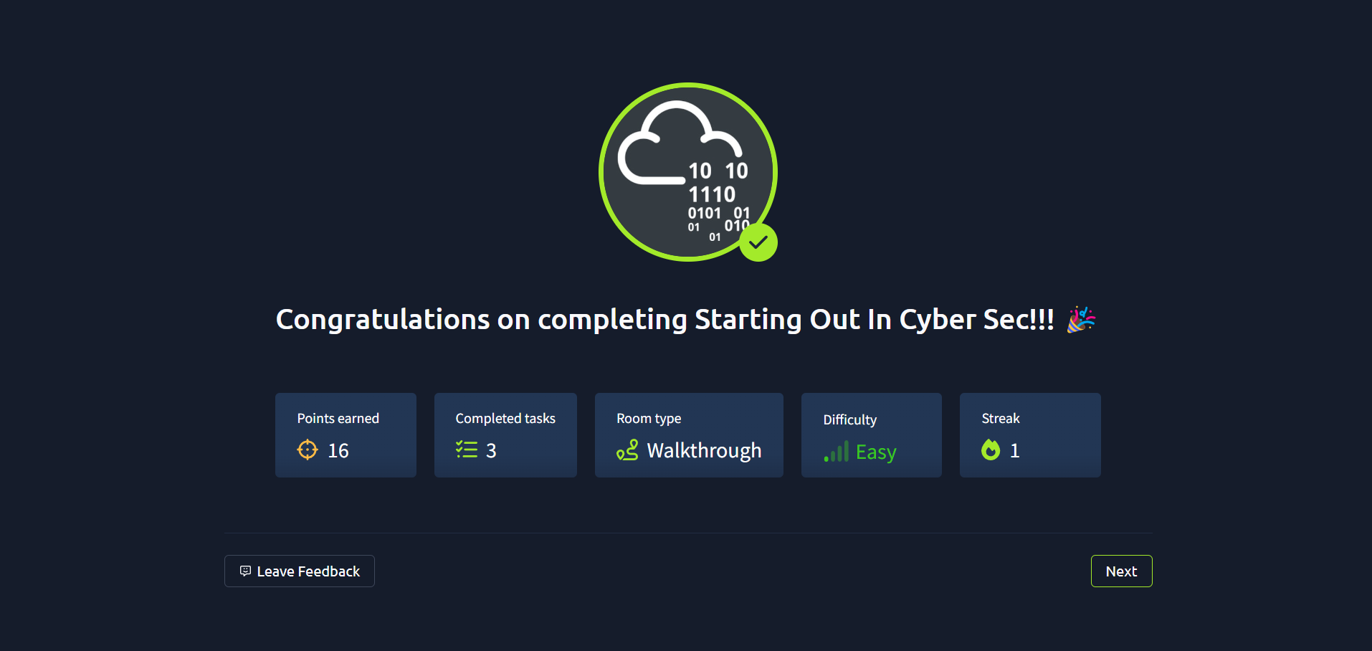

1. **Starting out in cyber security:**

* Room name and link: <https://tryhackme.com/room/startingoutincybersec>
* Learning objective: Gain awareness of different domains in cybersecurity and career opportunities.
* Key tools/commands used: None.
* Concepts learned: Cybersecurity fundamentals, career roles, offensive and defensive security.
* Walkthrough/ How you solved it: Studied the material, answered quiz-style questions.
* Reflections/ Notes: A great resource for setting long-term learning goals and understanding the field.

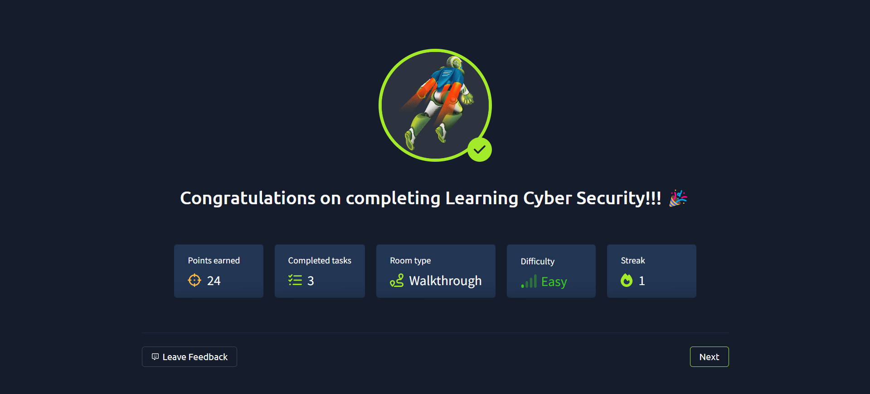

1. **Introduction to research:**

* Room name and link: <https://tryhackme.com/room/introtoresearch>
* Learning objective: Learn how to independently research and troubleshoot cybersecurity challenges.
* Key tools/commands used: Search engines, documentation, forums..
* Concepts learned: Open-source intelligence (OSINT), technical research skills.
* Walkthrough/ How you solved it: Followed case based tasks requiring the use of online resources and proper query formulation.
* Reflections/ Notes: Encourages a self-relaint learning attitude essential for long term growth in cybersecurity.

